Moodle Developer Environment Setup Guide

Moodle is normally run on a server setup, however, for plugin developers, it is probably easier to run Moodle standalone on their personal computer. This guide assumes you will be using a Windows machine.

1. To install Moodle for desktop, go to <https://download.moodle.org/windows/> and download the version of Moodle you would like to use (probably the latest version): If you would like to use the official documentation instead of this guide: <https://docs.moodle.org/39/en/Complete_install_packages_for_Windows#Second_-_start_the_webserver> then skip to step TODO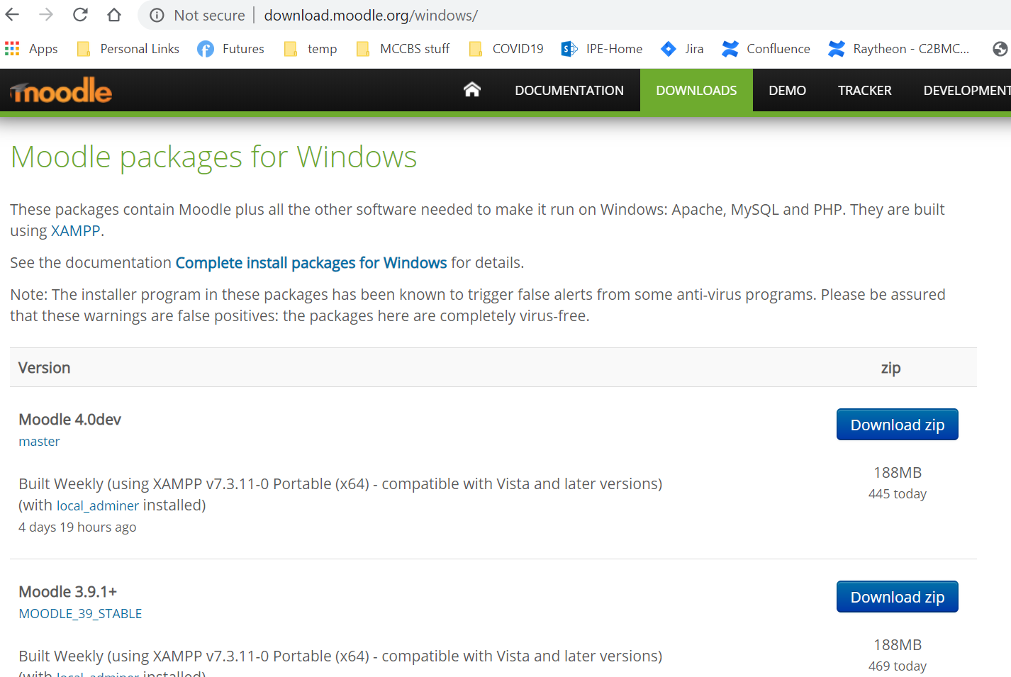
2. Click the “Download Zip” for the version you would like to use.
3. Unzip the downloaded Files to any folder location you would like to use, in this example we are going to put the downloaded files into “Moodle4.0” in our Downloads folder.
4. After unzipping and moving the moodle files, run “Start Moodle.exe” to set up the initial installation.
   1. Once “Start Moodle.exe” is running, do not close it to stop moodle, instead use the “stop Moodle.exe”
5. Now that Moodle is running, open a web browser and navigate to “localhost” or <http://127.0.0.1>
6. The first page will ask you to select your language of choice: 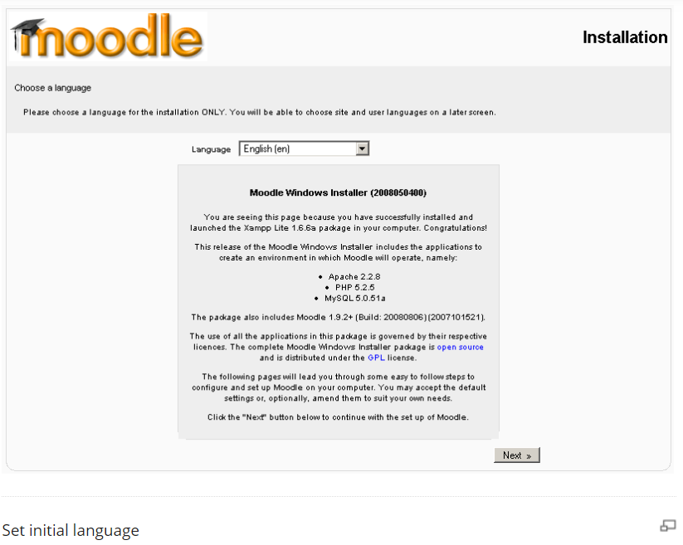
7. The next page will be a diagnostic report page, if it doesn’t look like this you’ll need to fix some things: 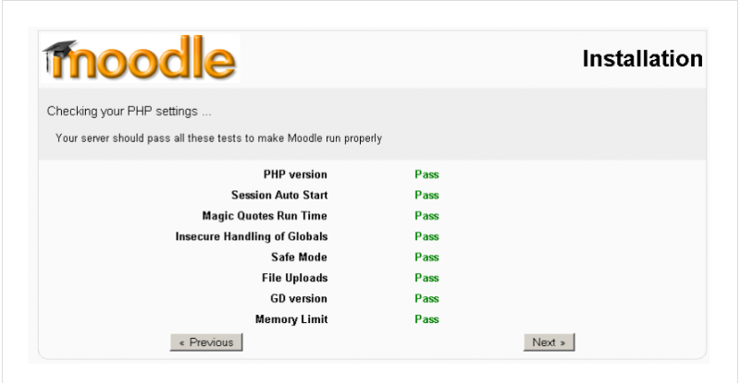
8. The next page will ask you to set up moodle installation locations: (for development on your own machine, just select the default, if you want it to be accessable via lan or Web address you will do that here as well: 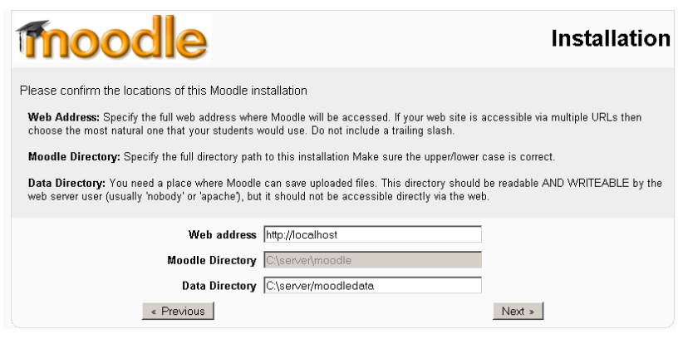
9. Next you will set up your database settings. You should probably set a password ( don’t forget it) but if this is just a local dev machine it probably doesn’t matter that much. 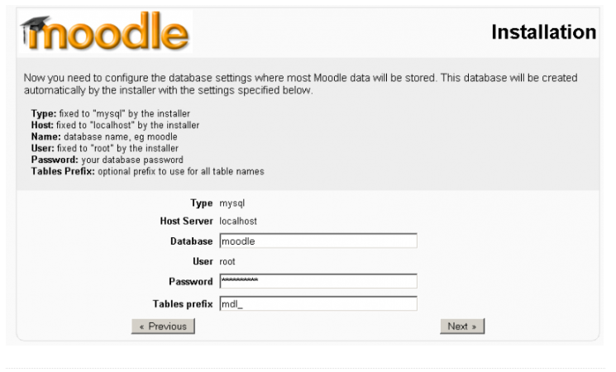
10. On the next page, moodle will run through a bunch of server checks(they should all be “OK”), wait till these are complete and press “next” 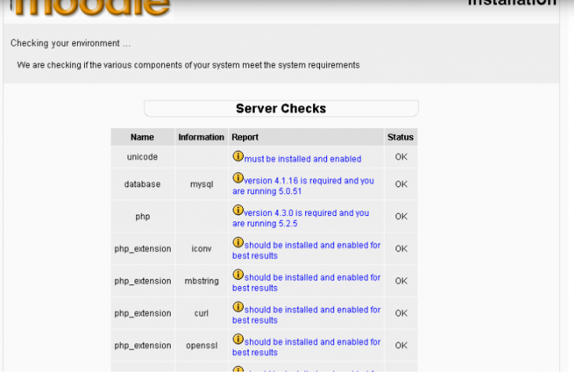
11. If you selected any additional language packs other than english, moodle will now check if it is available (if not it will just install using english): 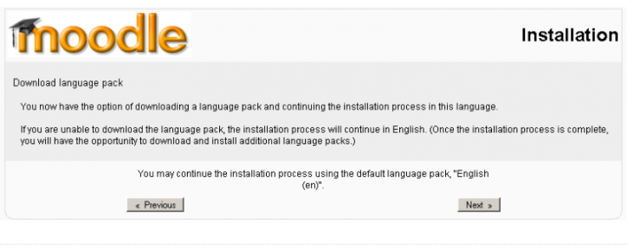
12. If everything completed successfully, a message confirming successful configuration will be displayed: 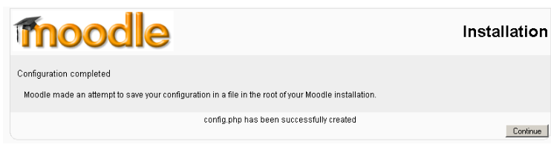
13. The next two screens will be copywrite/license notification and current release and unattended option, on the second screen, select the “unattended operation” checkbox to automatically advance through several installation screens 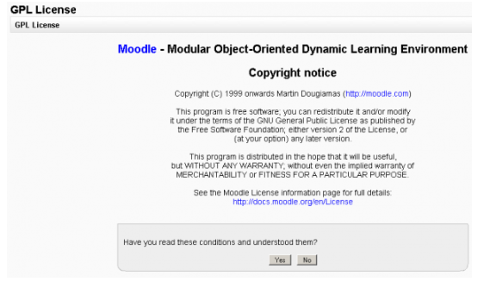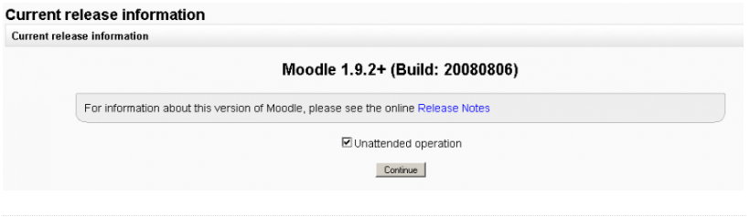
14. Wait for the next several screens to be finished installing, then you should see a “Setup administrator account” screen, create your administrator account and select “save” to continue: 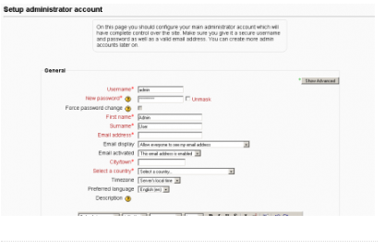
15. Next you will be asked to setup your full site name and a short name for the navigation bar, set these to whatever you want (you can change them later): 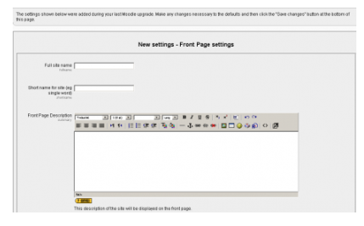
16. Next select if you want users to be able to setup their own account using their email (the default is to disable – as a developer machine you probably don’t care ( you can create user accounts using your administrator account)): 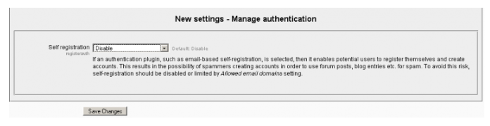
17. After selecting “save changes” above, you are DONE! Moodle is installed and you should be at your blank front page of your new site!: 